Chapter 3, Problem 62.

Find the mesh currents i_{1,} i₂, and i₃ in the network of Fig. 3.106.

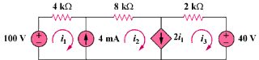

Figure 3.106
For Prob. 3.62.

